Preciso que resolva esse problema urgentemente

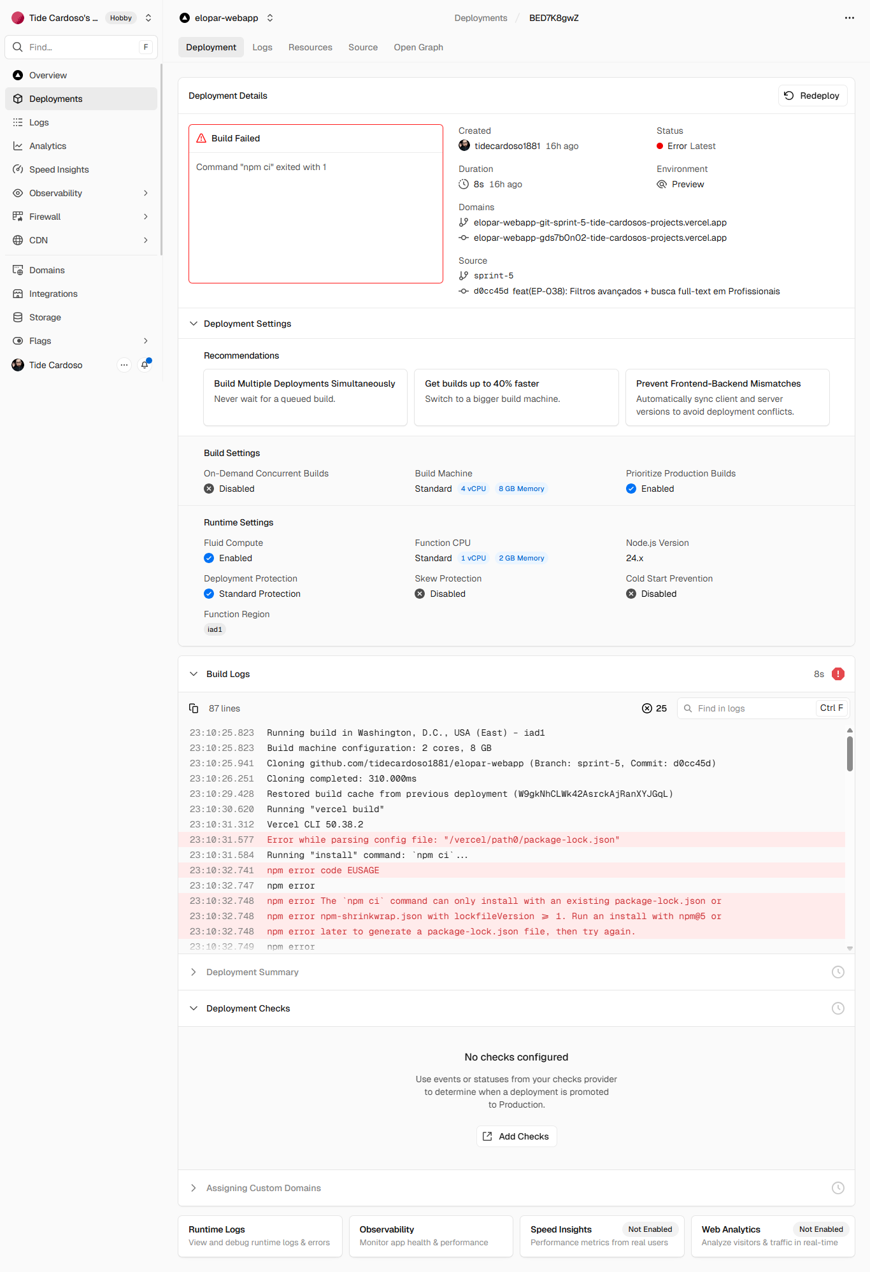

23:10:25.823 Running build in Washington, D.C., USA (East) – iad1
23:10:25.823 Build machine configuration: 2 cores, 8 GB
23:10:25.941 Cloning github.com/tidecardoso1881/elopar-webapp (Branch: sprint-5, Commit: d0cc45d)
23:10:26.251 Cloning completed: 310.000ms
23:10:29.428 Restored build cache from previous deployment (W9gkNhCLWk42AsrckAjRanXYJGqL)
23:10:30.620 Running "vercel build"
23:10:31.312 Vercel CLI 50.38.2
23:10:31.577 Error while parsing config file: "/vercel/path0/package-lock.json"
23:10:31.584 Running "install" command: `npm ci`...
23:10:32.741 npm error code EUSAGE
23:10:32.747 npm error
23:10:32.748 npm error The `npm ci` command can only install with an existing package-lock.json or
23:10:32.748 npm error npm-shrinkwrap.json with lockfileVersion >= 1. Run an install with npm@5 or
23:10:32.748 npm error later to generate a package-lock.json file, then try again.
23:10:32.749 npm error
23:10:32.749 npm error Clean install a project
23:10:32.749 npm error
23:10:32.750 npm error Usage:
23:10:32.750 npm error npm ci
23:10:32.750 npm error
23:10:32.750 npm error Options:
23:10:32.751 npm error [--install-strategy <hoisted|nested|shallow|linked>] [--legacy-bundling]
23:10:32.751 npm error [--global-style] [--omit <dev|optional|peer> [--omit <dev|optional|peer> ...]]
23:10:32.751 npm error [--include <prod|dev|optional|peer> [--include <prod|dev|optional|peer> ...]]
23:10:32.751 npm error [--strict-peer-deps] [--foreground-scripts] [--ignore-scripts]
23:10:32.752 npm error [--allow-git <all|none|root>] [--no-audit] [--no-bin-links] [--no-fund]
23:10:32.752 npm error [--dry-run]
23:10:32.752 npm error [-w|--workspace <workspace-name> [-w|--workspace <workspace-name> ...]]
23:10:32.752 npm error [--workspaces] [--include-workspace-root] [--install-links]
23:10:32.752 npm error
23:10:32.752 npm error --install-strategy
23:10:32.752 npm error Sets the strategy for installing packages in node_modules.
23:10:32.752 npm error
23:10:32.752 npm error --legacy-bundling
23:10:32.753 npm error Instead of hoisting package installs in `node_modules`, install packages
23:10:32.753 npm error
23:10:32.753 npm error --global-style
23:10:32.753 npm error Only install direct dependencies in the top level `node_modules`,
23:10:32.753 npm error
23:10:32.753 npm error --omit
23:10:32.754 npm error Dependency types to omit from the installation tree on disk.
23:10:32.754 npm error
23:10:32.754 npm error --include
23:10:32.754 npm error Option that allows for defining which types of dependencies to install.
23:10:32.755 npm error
23:10:32.755 npm error --strict-peer-deps
23:10:32.755 npm error If set to `true`, and `--legacy-peer-deps` is not set, then _any_
23:10:32.755 npm error
23:10:32.755 npm error --foreground-scripts
23:10:32.755 npm error Run all build scripts (ie, `preinstall`, `install`, and
23:10:32.756 npm error
23:10:32.756 npm error --ignore-scripts
23:10:32.756 npm error If true, npm does not run scripts specified in package.json files.
23:10:32.756 npm error
23:10:32.756 npm error --allow-git
23:10:32.757 npm error Limits the ability for npm to fetch dependencies from git references.
23:10:32.757 npm error
23:10:32.757 npm error --audit
23:10:32.757 npm error When "true" submit audit reports alongside the current npm command to the
23:10:32.757 npm error
23:10:32.758 npm error --bin-links
23:10:32.758 npm error Tells npm to create symlinks (or `.cmd` shims on Windows) for package
23:10:32.760 npm error
23:10:32.761 npm error --fund
23:10:32.761 npm error When "true" displays the message at the end of each `npm install`
23:10:32.761 npm error
23:10:32.761 npm error --dry-run
23:10:32.762 npm error Indicates that you don't want npm to make any changes and that it should
23:10:32.762 npm error
23:10:32.762 npm error -w|--workspace
23:10:32.762 npm error Enable running a command in the context of the configured workspaces of the
23:10:32.762 npm error
23:10:32.763 npm error --workspaces
23:10:32.763 npm error Set to true to run the command in the context of **all** configured
23:10:32.763 npm error
23:10:32.763 npm error --include-workspace-root
23:10:32.763 npm error Include the workspace root when workspaces are enabled for a command.
23:10:32.763 npm error
23:10:32.764 npm error --install-links
23:10:32.764 npm error When set file: protocol dependencies will be packed and installed as
23:10:32.764 npm error
23:10:32.764 npm error
23:10:32.764 npm error aliases: clean-install, ic, install-clean, isntall-clean
23:10:32.764 npm error
23:10:32.765 npm error Run "npm help ci" for more info
23:10:32.769 npm error A complete log of this run can be found in: /vercel/.npm/_logs/2026-04-06T02_10_31_806Z-debug-0.log
23:10:32.791 Error: Command "npm ci" exited with 1

